***Magic Tale***

**The First Shaman**

Game design:

Open world

10000 bc game

Fantasy

The game world will mostly be made of beautiful forests and lands full of mystery

Characters:

The hero of the game will be a custom made character and the game and story will change depending on your character and its choices.

I have not made many of the main characters yet at most I will make five main and 10 background characters.

Quest:

The first quest can be three things go hunt go forage or repair the tribe huts the first quest has a significant impact on the game and the progressing storyline

Base story:

As for the story I have not got the full idea but I am still thinking it up but the whole storyline does not matter what matters is I give the hero something to do I want this game to be massive and will defiantly not have the time to make the hole game so I will make some quest ideas for him to do and he can do that for the game.

But here’s what I got so far

You belong to the something-something tribe (the player can name his/her tribe)

Player intro:

“in the beginning of my life the tribe was doing great there was food, clean water a bountiful land and the days never looked brighter but sun shine and happiness was never meant for me.

There was a storm on the day I was born it made the land shake and the land tried to crush us my family dead in the storm and I was going to die to but the tribe chief gave his life to save mine ever since that day.

the land hated us the water terns to poison and the animals disappeared and monsters came for us and the bountiful land dead and the world became dark and cold to us my tribe soon came to the idea that my berth angered the gods and tried to get rid of me

I can’t blame them the day I was born the world died id hate me to but the tribe elder the former love of the chef stopped them I don’t know if she cared if I lived or if she wants to be the one to kill me but it does not mater I will defy the gods and save my tribe and bring back the land to its greatness for my tribe and myself.”

Objective:

Travelled around the world find the first magic’s save your people and fight the darkness that in destroying your world.

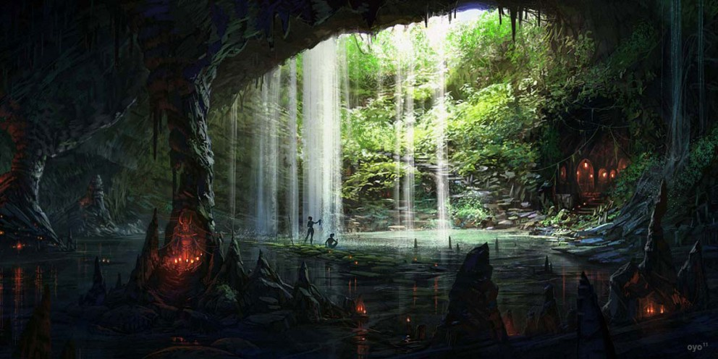Base ideas on what the map lands will look like.

This is what the home base will look like a cave with tribal look to it and I would like to add in some trees and big toad stools and more to give it the fantasy feel but at the same time I would like to have it all dark scenic to give a mystic feel to it at the same time giving it the feel that you and in the stone age.

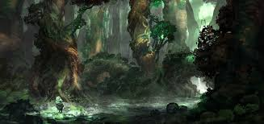

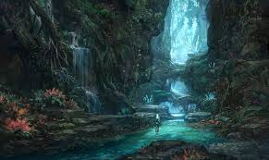

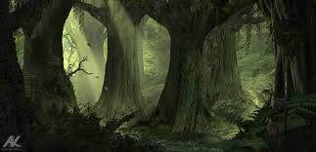

The three pics there are somewhat what I am going for and I would really like to have an in depth seasons changer so when the seasons change and if I can add a complex weather system to it so when the clouds build up to much you get rain and when it rains to much the land becomes flooded and if there’s to much sun and wind it can start a bush fire and if there’s hot storm lightning will shoot out and you have to protect your home but I would be happy if I can make beautiful fantasy forest that I want.